Name |  |  | Patha Akash | Course Title | AI Assisted Coding
Year/Sem |  |  | III/II | Regulation | R23
Date and Day  of Assignment |  |  | Week5 – Monday | Time(s) | 23CSBTB01 To 23CSBTB52
Id number |  |  | 2303A54041 | Applicable to  Batches | All batches
Assignment Number: 9.1(Present assignment number)/24(Total number of assignments)
 | 1 | Lab Experiment: Documentation Generation -Automatic documentation and code comments  Lab Objectives  - To understand automatic documentation generation.  - To generate code comments and docstrings using AI tools.  - To learn the importance of documentation in software development.  Lab Outcomes  - Students will be able to generate documentation automatically for code.  - Students will be able to add clear comments and docstrings to programs.  - Students will be able to improve code readability and maintainability using documentation.  Problem 1:  Consider the following Python function:  def find_max(numbers):  return max(numbers)  Task:  - Write documentation for the function in all three formats:  (a) Docstring  (b) Inline comments  (c) Google-style documentation  - Critically compare the three approaches. Discuss the advantages, disadvantages, and suitable use cases of each style.  - Recommend which documentation style is most effective for a mathematical utilities library and justify your answer.  PROMPT:  "can you document this python function in docstring, inline comment and google style format and compare all three?  CODE:  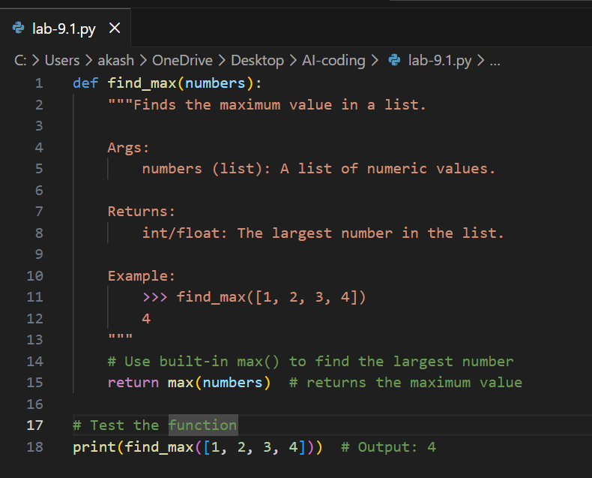  EXPLANATION:  This function takes a list of numbers and returns the largest value using Python's built-in max() function. It includes a Google-style docstring, inline comments to explain each step, and a test case to verify the output  OUTPUT:  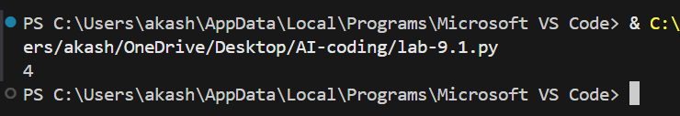 |  |  |  | Week5 -Monday
Problem 2: Consider the following Python function:
def login(user, password, credentials):
return credentials.get(user) == password
Task:
- Write documentation in all three formats.
- Critically compare the approaches.
- Recommend which style would be most helpful for new developers onboarding a project, and justify your choice.
PROMPT: "i have a python login function that checks if a username and password match stored credentials, can you document it in docstring, inline comments and google style format, compare all three and suggest which style is best for new developers?
CODE:
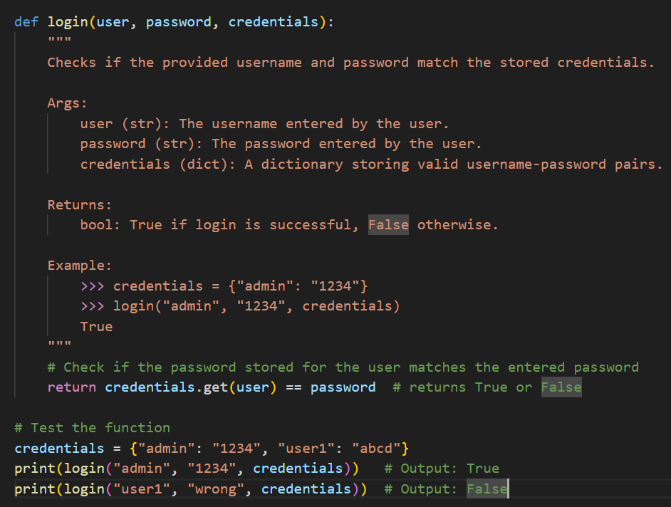
EXPLANATION:
This function checks if the entered username and password match the stored credentials and returns True if they match, otherwise False.

Problem 3: Calculator (Automatic Documentation Generation)
Task: Design a Python module named calculator.py and demonstrate automatic documentation generation.
Instructions:
- Create a Python module calculator.py that includes the following functions, each written with appropriate docstrings:
  - add(a, b) – returns the sum of two numbers
  - subtract(a, b) – returns the difference of two numbers
  - multiply(a, b) – returns the product of two numbers
  - divide(a, b) – returns the quotient of two numbers
- Display the module documentation in the terminal using Python’s documentation tools.
- Generate and export the module documentation in HTML format using the pydoc utility, and open the generated HTML file in a web browser to verify the output.

CODE:
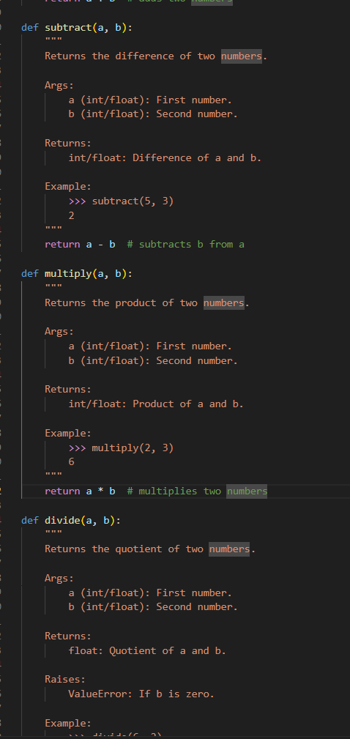

EXPLANATION:
This module contains four basic arithmetic functions with proper docstrings and uses Python's pydoc tool to automatically generate documentation in the terminal and as an HTML file.

OUTPUT:
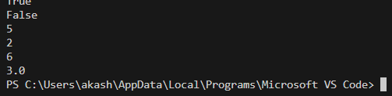
Problem 4: Conversion Utilities Module
Task:
- Write a module named conversion.py with functions:
  - decimal_to_binary(n)
  - binary_to_decimal(b)
  - decimal_to_hexadecimal(n)
- Use Copilot for auto-generating docstrings.
- Generate documentation in the terminal.
- Export the documentation in HTML format and open it in a browser.
PROMPT:
can you write a python module called conversion.py with three functions to convert decimal to binary, binary to decimal and decimal to hexadecimal with proper docstrings and how to generate documentation using pydoc?"

CODE:
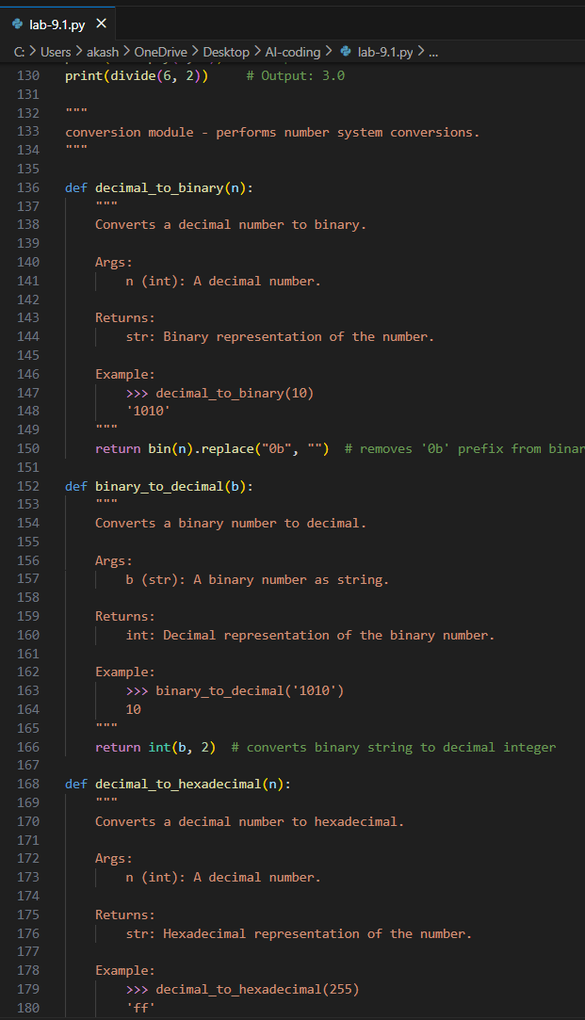

EXPLANATION:
This module contains three functions that convert numbers between decimal, binary, and hexadecimal formats, and uses Python's pydoc tool to automatically generate documentation in the terminal and as an HTML file.

OUTPUT:
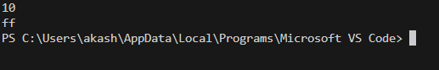

Problem 5 – Course Management Module
Task:
- Create a module course.py with functions:
  - add_course(course_id, name, credits)
  - remove_course(course_id)
  - get_course(course_id)
- Add docstrings with Copilot.
- Generate documentation in the terminal.
- Export the documentation in HTML format and open it in a browser.

PROMPT:
can you write a python module called course.py with three functions to add, remove and get a course with proper docstrings and how to generate documentation using pydoc?
CODE:
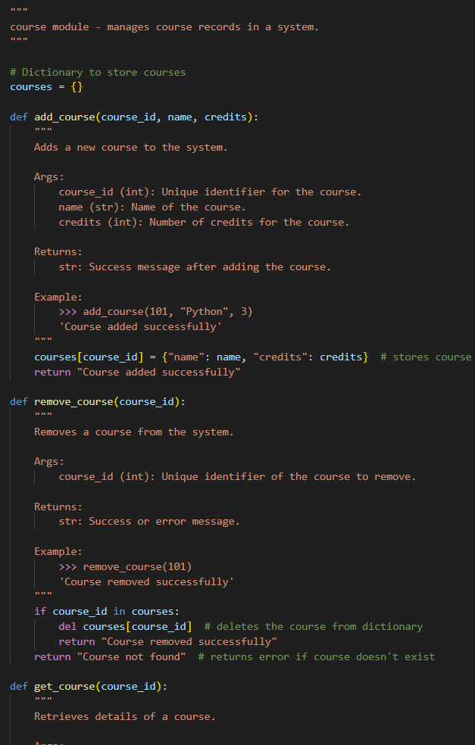

OUTPUT:
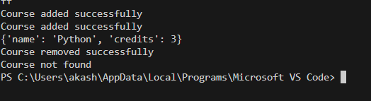
EXPLANATION:
This module manages course records using a dictionary with three functions to add, remove, and retrieve courses, and uses Python's pydoc tool to automatically generate documentation in the terminal and as an HTML file

